Functional Requirement of Customer Application of Claims And Support

**1. Admin Login:**

- This feature allows administrators to securely log into the system using their credentials. It ensures that only authorized personnel can access the admin dashboard.

**2. User Login:**

- Users can log into the system using their credentials, providing access to personalized features and information related to their insurance policies and claims.

**3. Admin Dashboard:**

- The admin dashboard serves as the central hub for administrators to manage and monitor various aspects of the insurance system. It provides a comprehensive overview of system statistics, pending tasks, and access to administrative functionalities.

**4. User Dashboard:**

- The user dashboard provides insurance policy holders with a personalized interface where they can view their insurance details, file claims, track claim status, and manage their policies. It offers a user-friendly experience and easy navigation.

**5**. **Login**:

- This component represents the login functionality, allowing users to authenticate themselves and gain access to the respective dashboards.

**6. Insurance Files:**

- This section enables administrators to manage and organize insurance-related documents and files securely. It provides a centralized repository for storing and retrieving important documents.

**7. Active Insurance Holders:**

- This feature allows administrators to view and manage a list of active insurance policyholders. It provides details such as policy numbers, coverage information, and contact details.

**8. Insurance Claims:**

- Users can file insurance claims through this feature. They can enter relevant details, upload supporting documents, and submit the claim for processing.

**9. Insurance Approvals:**

- Administrators review and approve or reject insurance claims through this module. They can assess the validity of claims, request additional information if needed, and make informed decisions.

**10. Withheld Claims:**

- This will lists claims that require further investigation or additional documentation. Administrators can place claims on hold pending further review.

**11. User Insurance:**

- This component displays information about the insurance policies owned by individual users. It provides a summary of coverage, premium payments, and other policy details.

**12. Insurance Details:**

- Users can access detailed information about their insurance policies, including coverage limits, deductibles, and policy terms. This section offers a comprehensive view of policy specifics.

**13. Insurance Claims (Accidental, Disease, Vehicle):**

- This segment represents different types of insurance claims that users can file based on the nature of the incident, such as accidental claims, disease-related claims, and vehicle-related claims.

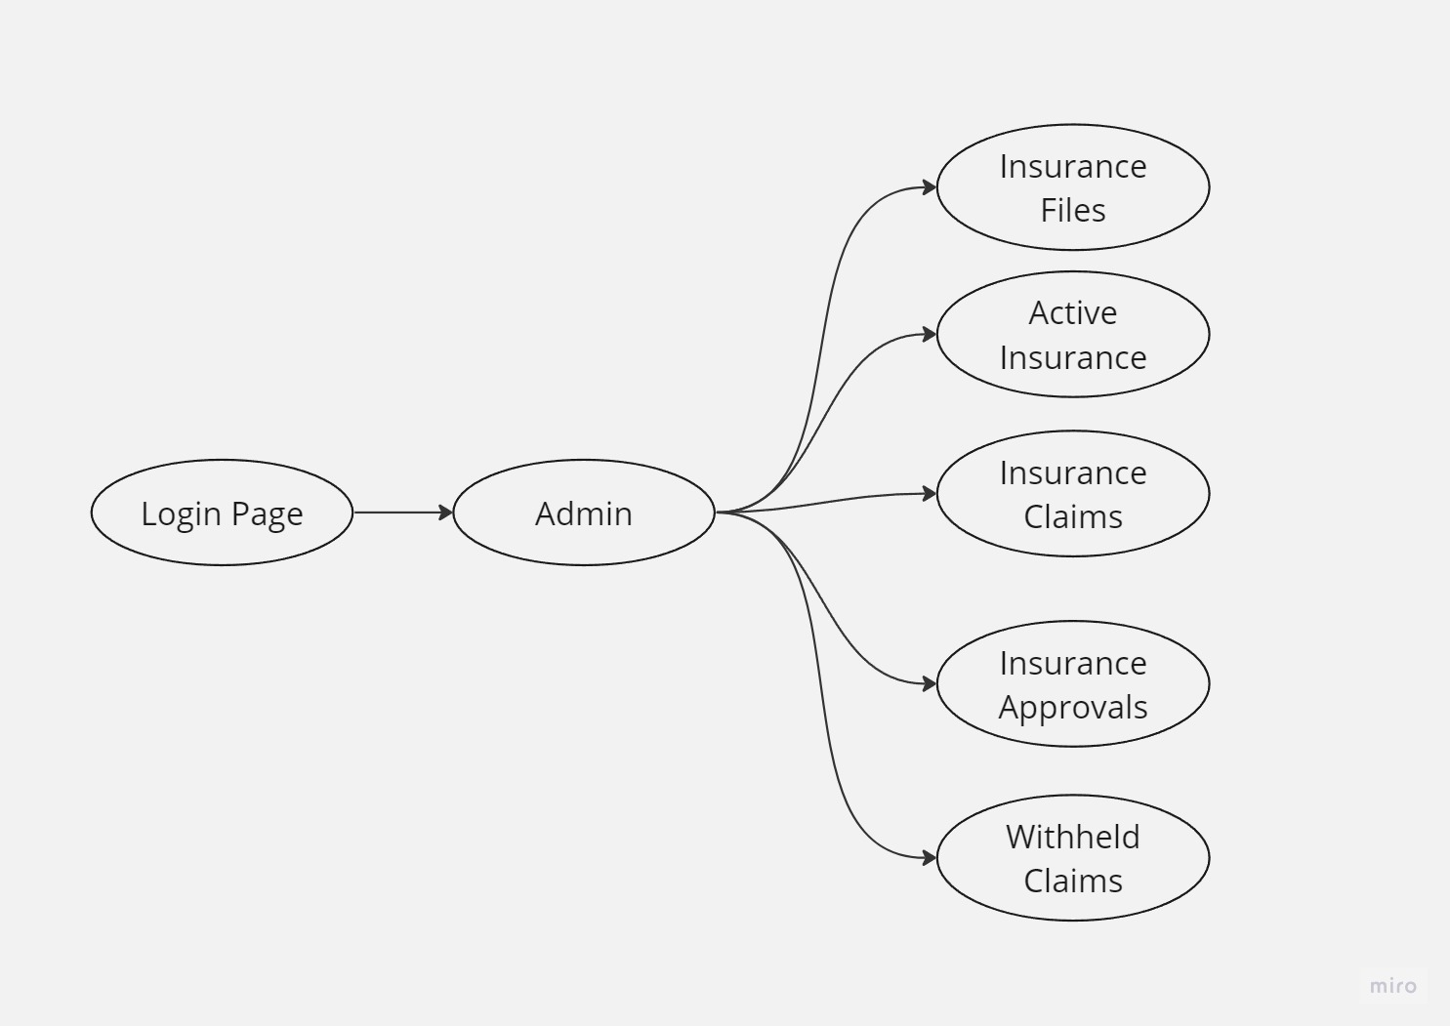

**Admin:**

LOGIN>Admin >Admin dashboard>Insurance files

LOGIN>Admin >Admin dashboard>Active Insurance holders

LOGIN>Admin >Admin dashboard>Insurance claims

LOGIN>Admin >Admin dashboard>Insurance approvals

LOGIN>Admin >Admin dashboard>Withheld claims

**Insurance Files:**

**Field Name Description**

|  |  |
| --- | --- |
| File ID | Unique identifier for the insurance file |
| Policy Holder | Name of the insurance policy holder |
| Policy Number | Number associated with the insurance policy |

|  |  |
| --- | --- |
| Insurance Company | Name of the insurance company |
| Start Date | Date when the insurance coverage begins |
| End Date | Date when the insurance coverage ends |

**Active Insurance Holders:**

**Field Name Description**

|  |  |
| --- | --- |
| Policy Holder | Name of the insurance policy holder |
| Policy Number | Number associated with the insurance policy |
| Insurance Company | Name of the insurance company |
| Start Date | Date when the insurance coverage begins |
| End Date | Date when the insurance coverage ends |
| Premium Amount | Amount paid for the insurance premium |

**Insurance Claims:**

**Field Name Description**

|  |  |
| --- | --- |
| Claim ID | Unique identifier for the insurance claim |
| Policy Holder | Name of the insurance policy holder |
| Policy Number | Number associated with the insurance policy |
| Date Filed | Date when the insurance claim was filed |
| Claim Amount | Amount claimed in the insurance |
| Status | Current status of the insurance claim |

**Insurance Approvals:**

**Field Name Description**

|  |  |
| --- | --- |
| Approval ID | Unique identifier for the insurance approval |
| Policy Holder | Name of the insurance policy holder |
| Policy Number | Number associated with the insurance policy |
| Approval Date | Date when the insurance claim was approved |
| Approved Amount | Amount approved for the insurance claim |
| Status | Current status of the insurance approval |

**Withheld Claims:**

**Field Name Description**

|  |  |
| --- | --- |
| Claim ID | Unique identifier for the withheld claim |
| Policy Holder | Name of the insurance policy holder |
| Policy Number | Number associated with the insurance policy |
| Date Filed | Date when the insurance claim was filed |
| Claim Amount | Amount claimed in the insurance |
| Withheld Reason | Reason for withholding the insurance claim |

**To Manage Insurance Files**

a. Login to the system as an admin.

b. Access the admin dashboard.

c. Look for the option "Insurance Files" in the menu and click on it.

d. From the list of insurance files, select the file you want to edit or click "Add New" to create a new file.

e. Once you've selected a file, click on the menu and choose "View/Edit" to make changes.

f. Modify the fields such as File ID, Policy Holder, Policy Number, Insurance Company, Start Date, End Date, or Premium Amount as required.

g. After making the necessary changes, click the "Save" button to save the updated information.

**To Manage Active Insurance Holders**

a. Login to the system as an admin.

b. Access the admin dashboard.

c. Locate and click on the "Active Insurance Holders" option in the menu.

d. Select the specific policy holder from the list that you want to edit or click "Add New" to add a new

active insurance holder.

e. Click on the menu and choose "View/Edit" to edit the details.

f. Update the fields such as Policy Holder, Policy Number, Insurance Company, Start Date, End Date,

or Premium Amount as needed.

g. Once you've made the necessary changes, click the "Save" button to save the modifications.

**To Manage Insurance Claims**

a. Login to the system as an admin.

b. Go to the admin dashboard.

c. Look for the "Insurance Claims" option in the menu and click on it.

d. Choose the specific claim from the list that you want to edit or click "Add New" to create a new

claim.

e. Click on the menu and select "View/Edit" to access the claim details.

f. Make the required changes in fields like Claim ID, Policy Holder, Policy Number, Date Filed, Claim

Amount, or Status.

g. After updating the necessary information, click the "Save" button to save the changes.

**To Manage Insurance Approvals**

a. Login to the system as an admin.

b. Access the admin dashboard.

c. Locate and click on the "Insurance Approvals" option in the menu.

d. Select the approval entry from the list that you want to edit or click "Add New" to create a new

approval.

e. Click on the menu and choose "View/Edit" to edit the approval details.

f. Update the fields such as Approval ID, Policy Holder, Policy Number, Approval Date, Approve

Amount, or Status.

g. Once you've made the necessary changes, click the "Save" button to save the modifications.

**To Manage Withheld claims**

a. Login to the system as an admin.

b. Go to the admin dashboard.

c. Look for the "Withheld Claims" option in the menu and click on it.

d. Select the withheld claim from the list that you want to edit or click "Add New" to add a new

withheld claim.

e. Click on the menu and select "View/Edit" to access the claim details.

f. Make the required changes in fields like Claim ID, Policy Holder, Policy Number, Date Filed, Claim

Amount, or Withheld Reason.

g. After updating the necessary information, click the "Save" button to save the changes.

**User:**

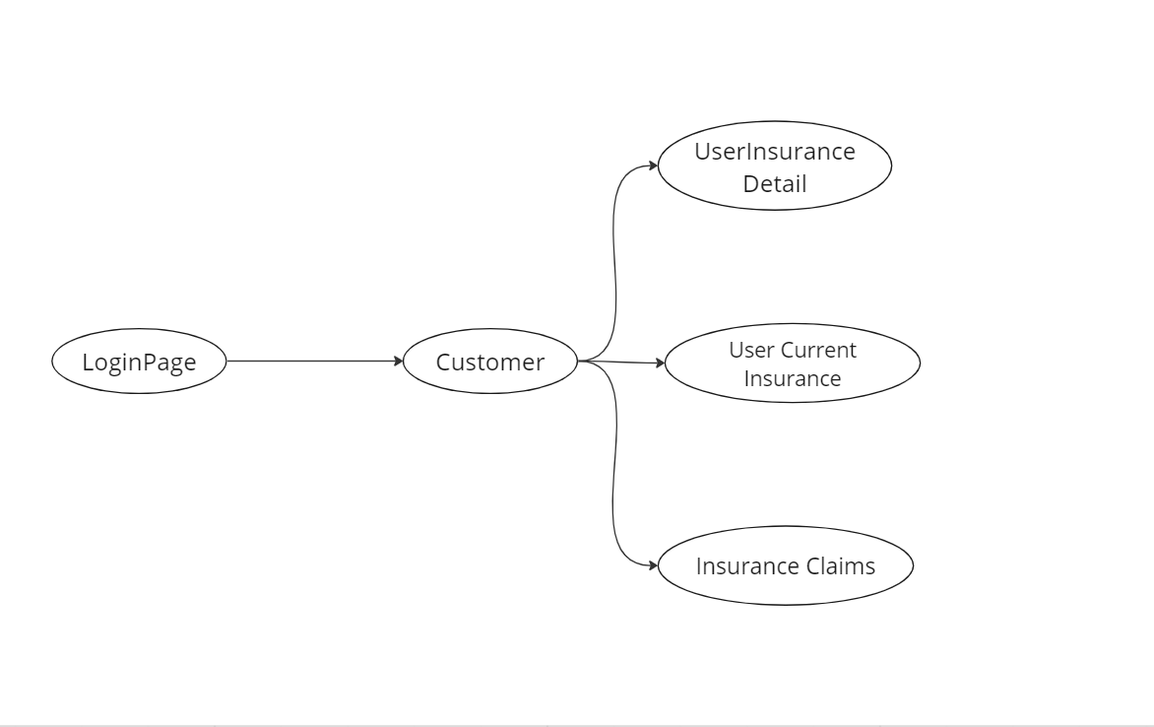

Login->User->User Dashboard->User Insurance->Insurance Type->Insurance Coverage->Description

Login->User->User Dashboard->Insurance Details

Login->User->User Dashboard->Insurance Claims

Login->User->User Dashboard->Active Holders

**Insurances:**

**Field Name Description**

|  |  |
| --- | --- |
| Insurance Type | The type or category of insurance coverage |
| Insurance Coverage | Details about the insurance coverage |

**Insurance Details:**

**Field Name Description**

|  |  |
| --- | --- |
| Policy Number | The unique identifier of the insurance policy |
| Coverage Type | The type of insurance coverage |
| Effective Dates | The start and end dates of the insurance coverage |
| Premium Amount | The amount paid for the insurance premium |
| Beneficiary | The person or entity designated as the beneficiary of the insurance policy |

**Insurance Claims:**

**Field Name Description**

|  |  |
| --- | --- |
| Claim ID | The unique identifier for the insurance claim |
| Policy Holder | The name of the insurance policy holder |
| Policy Number | The number associated with the insurance policy |
| Date Filed | The date when the insurance claim was filed |
| Claim Amount | The amount claimed in the insurance |
| Status | The current status of the insurance claim |

**Active Holders:**

**Field Name Description**

|  |  |
| --- | --- |
| Policy Holder | The name of the insurance policy holder |
| Policy Number | The number associated with the insurance policy |
| Insurance Company | The name of the insurance company |
| Start Date | The date when the insurance coverage begins |
| End Date | The date when the insurance coverage ends |
| Premium Amount | The amount paid for the insurance premium |

**1. Insurance Type:**

- The user can view the available insurance types, such as life insurance, health insurance, auto insurance, etc., in this section.

- The information is displayed for the user to understand the different types of insurance coverage available.

**2. Insurance Coverage:**

- This section provides detailed information about the insurance coverage.

- The user can access information such as policy terms, coverage limits, deductibles, and additional benefits or riders associated with their insurance coverage.

- It helps the user understand the extent and scope of their insurance policy.

**3. Description:**

- The "Description" field provides additional details or specific information about the insurance policy, coverage, or terms.

- It may include explanations, clarifications, or specific instructions related to the user's insurance coverage.

**4. Insurance Details:**

- In the "Insurance Details" section, the user can view comprehensive information about their insurance policy.

- The details typically include the policy number, coverage type, effective dates (start and end dates) of the insurance coverage, premium amount paid by the user, and beneficiary details.

- The user can review and reference this information to understand their policy and coverage.

**5. Insurance Claims:**

- In the "Insurance Claims" section, the user can access information related to their insurance claims.

- The user can view the claim ID (a unique identifier for each claim), the policy holder's name, policy number, date filed (when the claim was submitted), claim amount (the amount claimed in the insurance), and the current status of the claim.

- This section allows the user to track the progress and status of their insurance claims.

**6. Active Holders:**

- The "Active Holders" section provides a list of insurance policy holders who have active insurance coverage.

- The user can view details such as the policy holder's name, policy number, insurance company, start date (when the insurance coverage began), end date (when the insurance coverage ends), and the premium amount paid.

- It helps the user identify other individuals or entities with active insurance coverage and review relevant information.

To interact with these sections, the user would typically follow these steps:

1. Login to the system as a user.

2. Access the user dashboard.

3. Navigate to the respective sections such as "Insurance Type," "Insurance Coverage," "Insurance Details," "Insurance Claims," or "Active Holders" by selecting the corresponding menu options.

4. The user can view the information presented in each section and review the relevant details.

5. If applicable, the user can interact with specific elements within each section, such as clicking on a claim ID to view more details about a particular claim.

6. The user can navigate back to the user dashboard or other sections as needed.